Alo Screen Reader
Installation Guide

1. Locate the Installer
1. Go to the Application (EXE) Folder
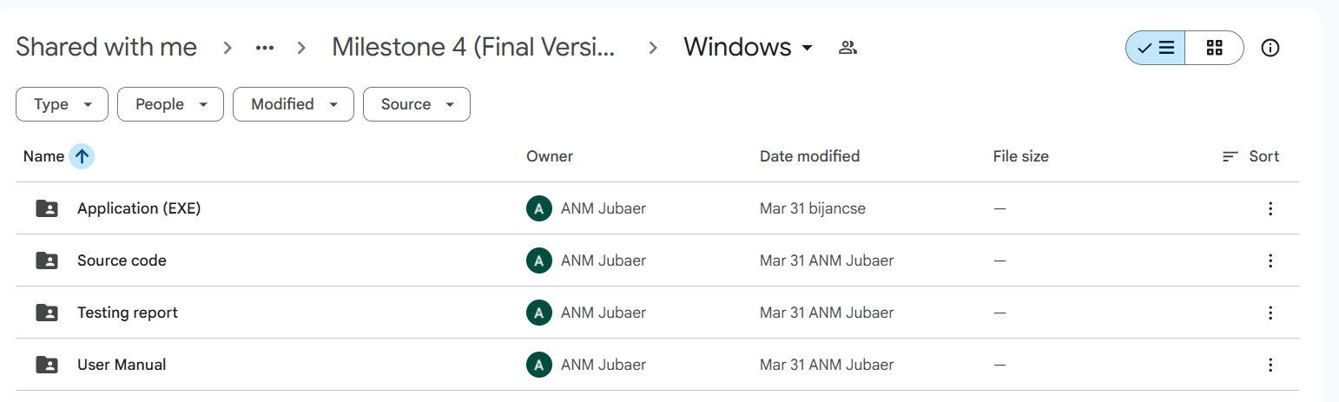
2. Now Download the zip file and extract it
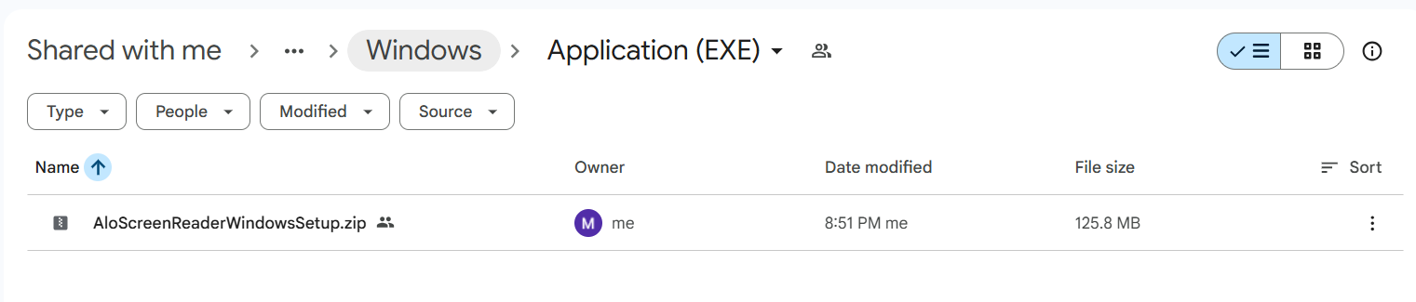
2. Install the exe file
3. Double-click to start installation.


2. Open Setup File
1. Confirm file selection and launch installer.
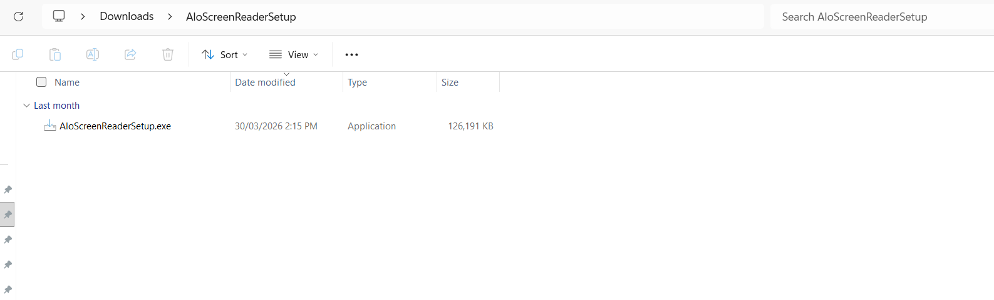

3. Select Destination Location
1. Choose the installation folder.
2. Default location is recommended.
3. Click Next.
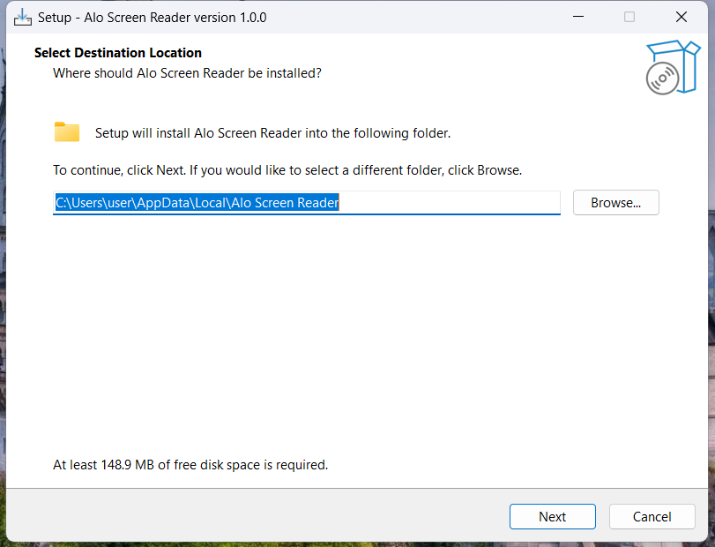

4. Select Start Menu Folder
1. Choose Start Menu folder name.
2. Click Next.
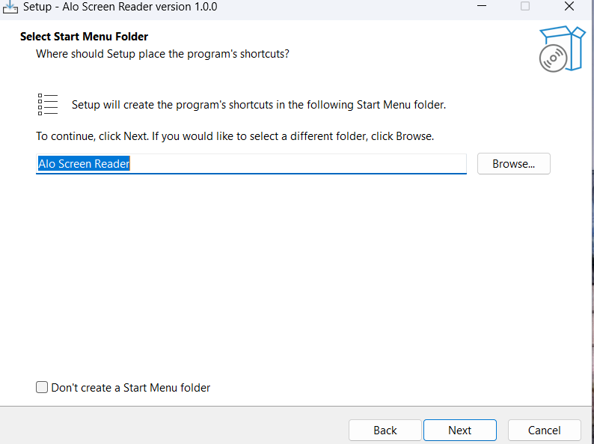

5. Additional Tasks
1. Select Create Desktop Shortcut.
2. Click Next.
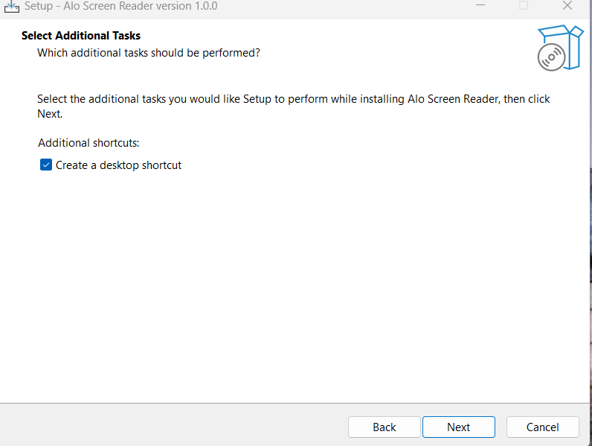

6. Ready to Install
1. Review settings carefully.
2. Click Install.
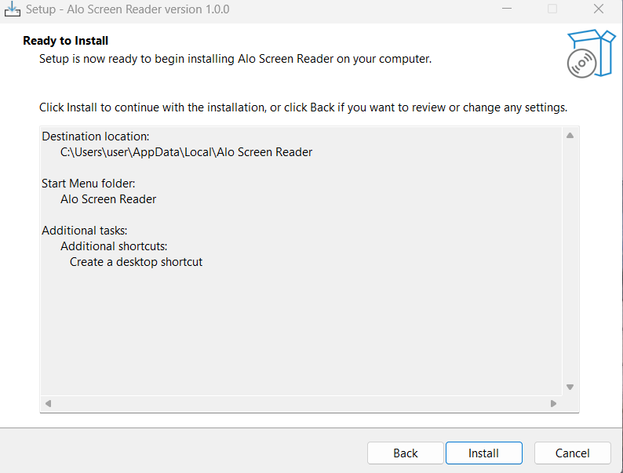

7. Installing
1. Wait while installation completes.
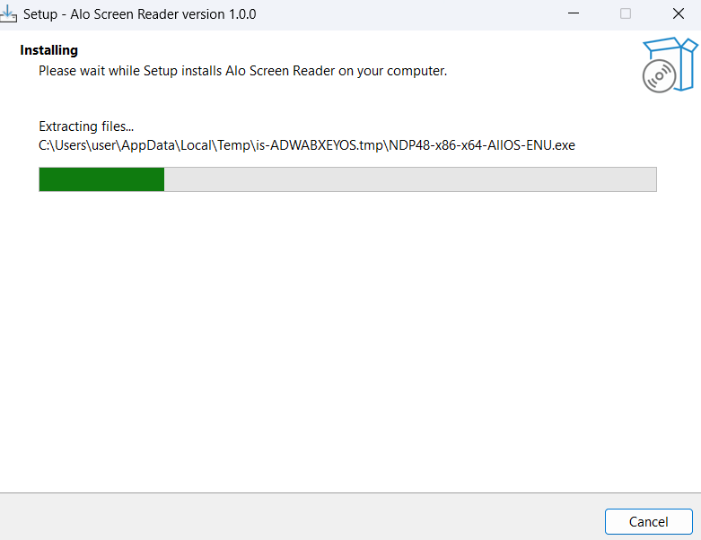

8. Finish Installation
1. Check Launch option.
2. Click Finish.
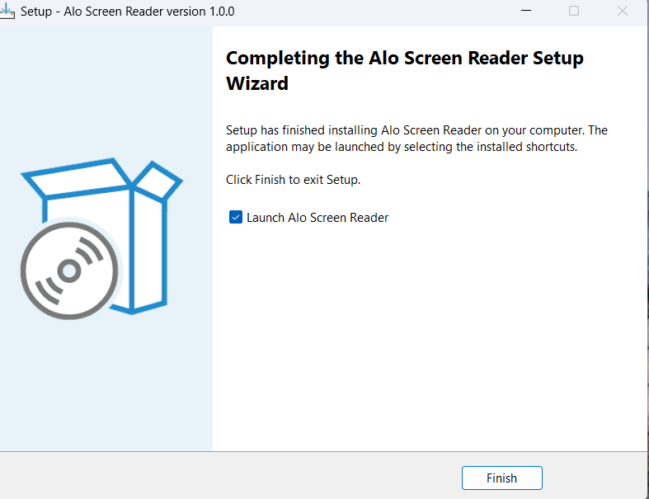

9. Application Launch
1. Application opens successfully.
2. Use menu options to navigate.
